York Castle Museum
Physical Accessibility
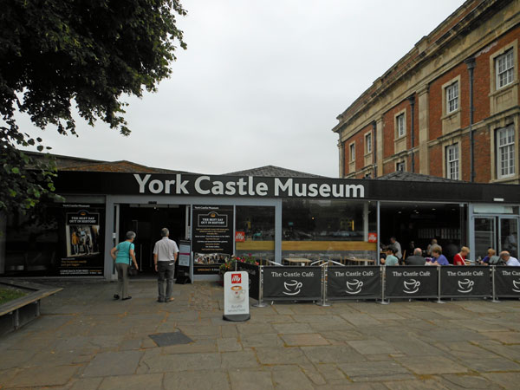

Information about your visit

Introduction
Welcome to the York Castle Museum. Before you begin your visit, this guide highlights any physical accessibility restrictions you may face within the museum.

The Basics
- The museum consists of three main buildings: the Reception, the Debtors’ Prison and the Female Prison.
- The majority of the museum is fully accessible to all. However, the upper floors of the Female Prison Building may be inaccessible to some visitors; further details follow on pages 3 to 6.
- The museum apologises for any inconvenience caused. Due to the Female Prison building being listed and its general design (it is spread over 6 levels), it has not been possible to provide a lift to grant access. However, we are continually working on improving our accessibility and any feedback/ideas are welcome.
- The museum has a supply of walking sticks and a wheelchair to borrow on a first come, first served basis.
- There are seating areas on all of our galleries.

The Price
- An Adult ticket (for people aged 25+) = £10.
- 17-24 year olds = £5.
- Under 16 year olds = Free.
- Access: Wheelchair Users = £5 (this price is reduced as parts of the museum are inaccessible other than via stairs).
- £5 Access tickets are also available to people on certain benefits.
- Carers = Free (one carer per person)
- Visitors who purchase the £10 ticket, but find part of the museum inaccessible, are entitled to a £5 refund.
- There is a YMT Membership Card available that grants access for a year to the York Castle Museum, the Yorkshire Museum and the York Art Gallery. It is £22 for adults and £11 for anyone that is eligible for an Access ticket. Please ask a staff member for more details.
Reception
- This is where you enter the museum.
- It contains an Admissions desk, the museum shop and a café.
- It is spread over a single level and is fully accessible.

The Debtors’ Prison
- This building is spread over two levels and is fully accessible.
- It consists of 3 exhibitions: the WW1 gallery, the 1960s gallery and the Prison Cells gallery; there is also an outside area.
- The WW1 gallery is located on the first floor and is fully accessible via a lift (measurements in inches= 68h x 40l x 30w) or 16 “up” stairs.
- The 1960s gallery, the Prison Cells gallery and the outside area are located on the ground floor. Some of the prison cells have narrow doorways and may not be accessible to those using mobility aids.

The Female Prison
- This building is spread over 6 levels and some visitors may find the upper floors inaccessible.
- It consists of 4 exhibitions: the Victorian Street gallery, the Period Rooms gallery, the Toy gallery, and the Shaping the Body galleries.
- The Victorian Street gallery is located on the ground floor and is fully accessible. Part of the gallery consists of cobbled flooring, but there is a path around the cobbles.
- The other galleries are located on the upper floors of this building. They are spread over 5 different levels and are only accessible via stairs.
- Any visitors using a walking frame are entitled to access the upper floors. However, the visitor must be with someone that can carry the walking frame up and down the stairs; unfortunately, museum staff are not able to help with any lifting.
- In total, there are 93 stairs (46 “up” and 47 “down”) spread over 6 staircases. The most stairs you have to go up in one go is 19. The most stairs you have to go down in one go is also 19.
- Pictures of all the staircases are shown on the following pages.
- The Period Rooms gallery is accessed via this staircase. There are 19 “up” stairs.
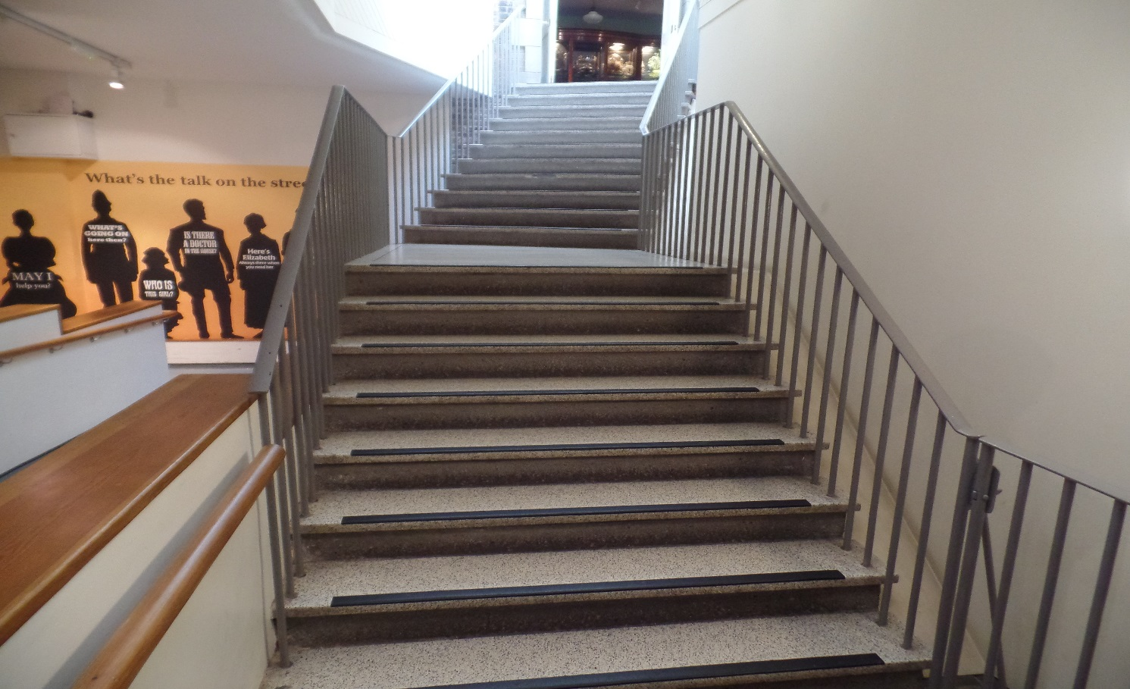

- The Toy gallery is accessed via this staircase. There are 19 “up” stairs.
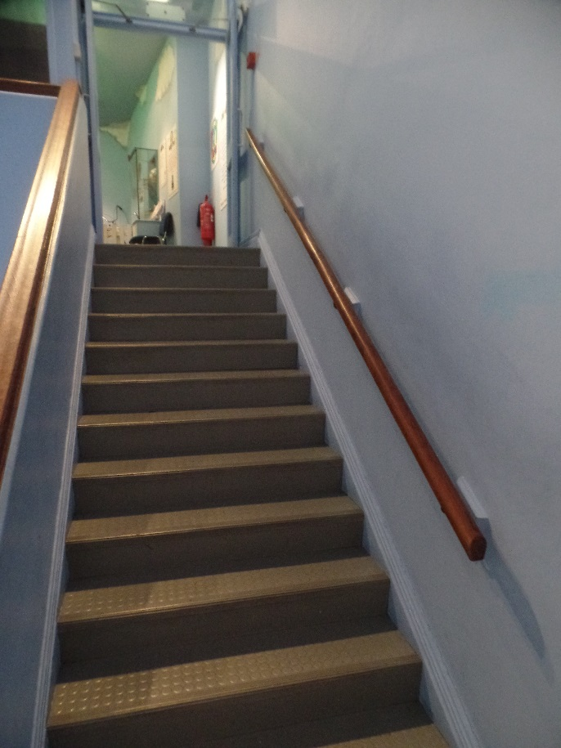
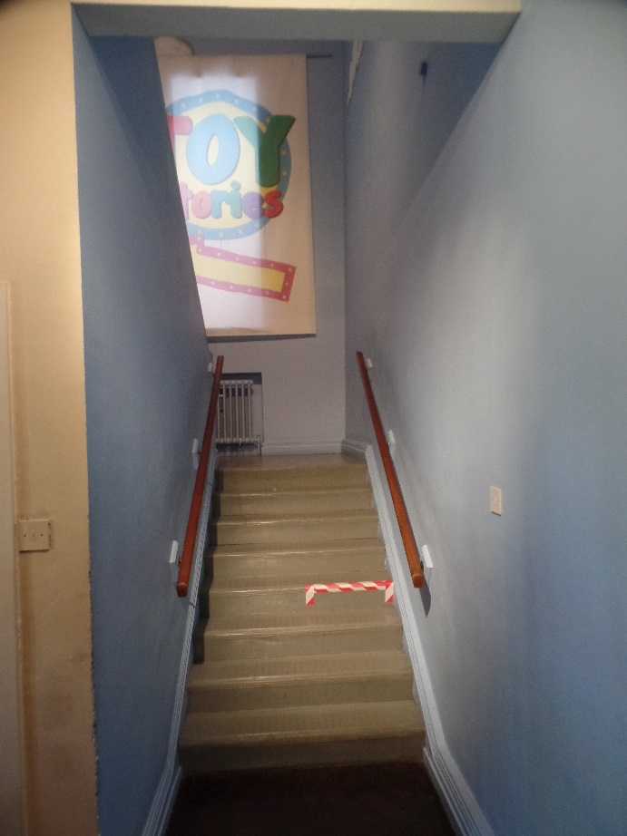

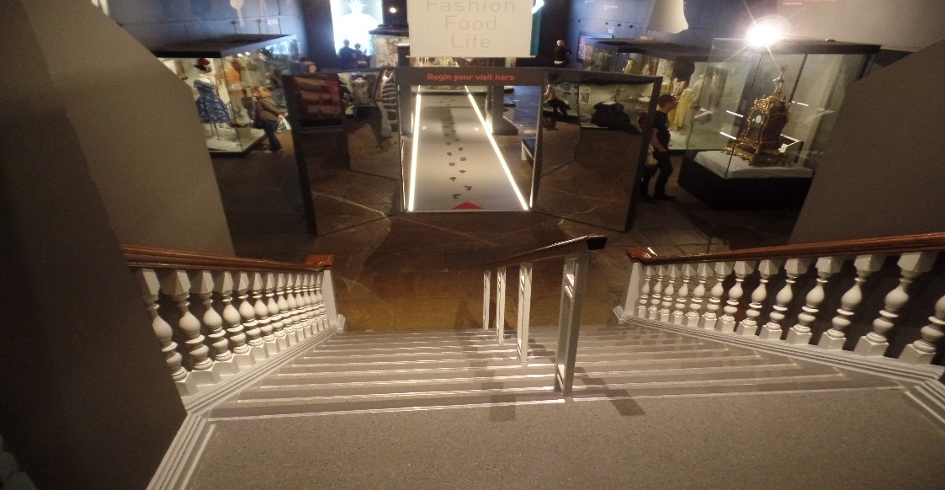
- The Fashion section of the Shaping the Body gallery is accessed via this staircase. There are 10 “down” stairs.

- The Food section of the Shaping the Body gallery is accessed via this staircase. There are 8 “up” stairs.
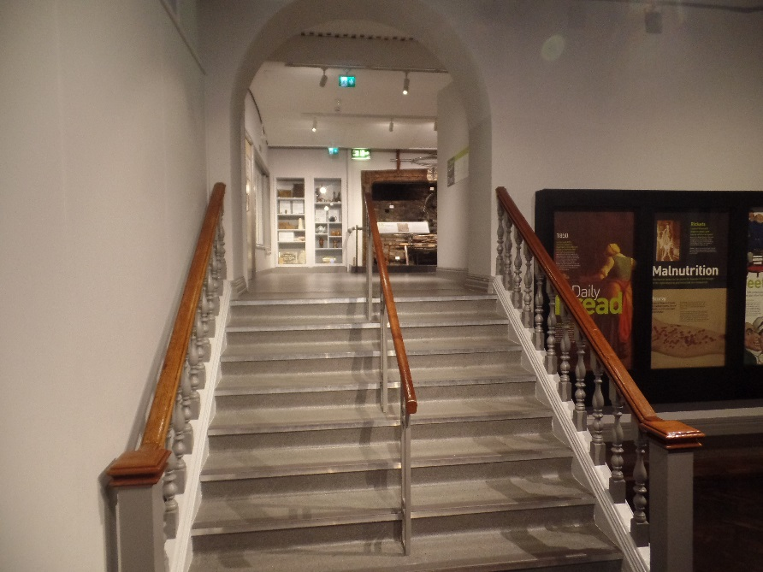

- The Life section of the Shaping the Body gallery is accessed via this staircase. There are 18 “down” stairs.
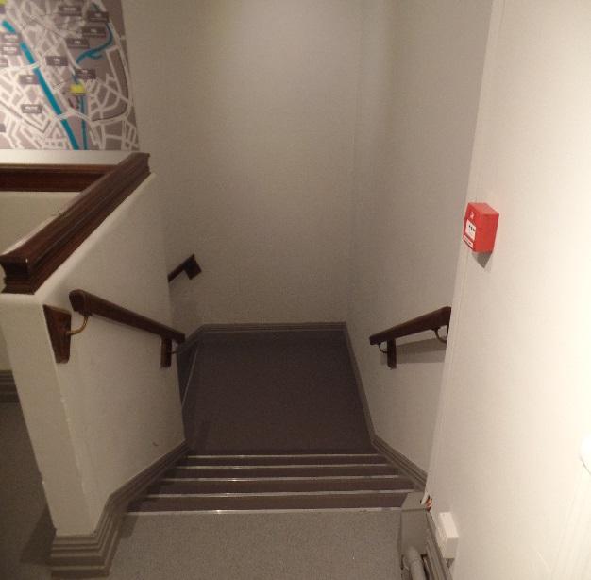
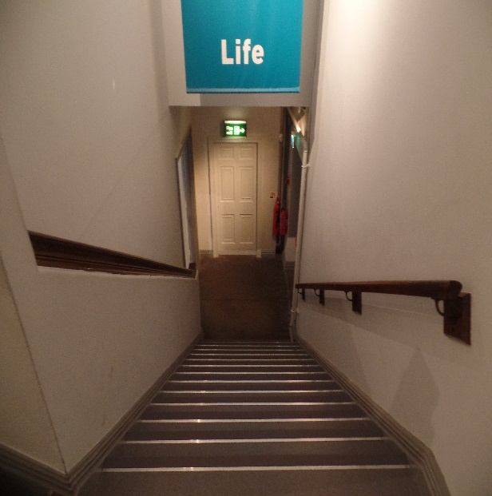

- The Victorian Street gallery is accessed via this staircase. There are 19 “down” stairs. This is the last gallery in the Female Prison.
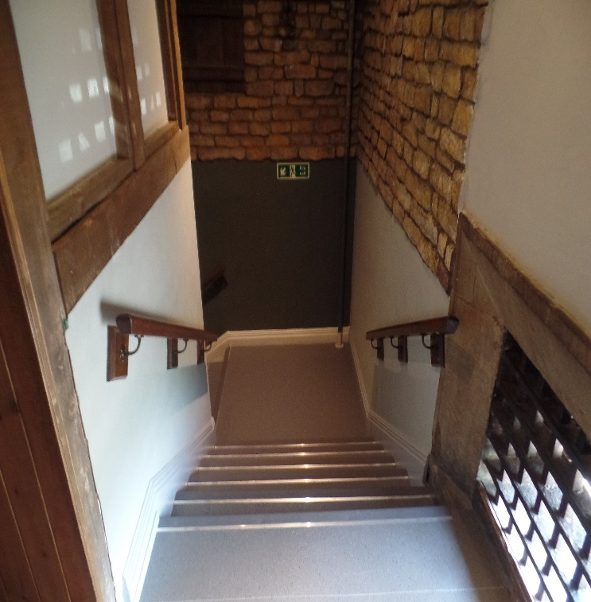
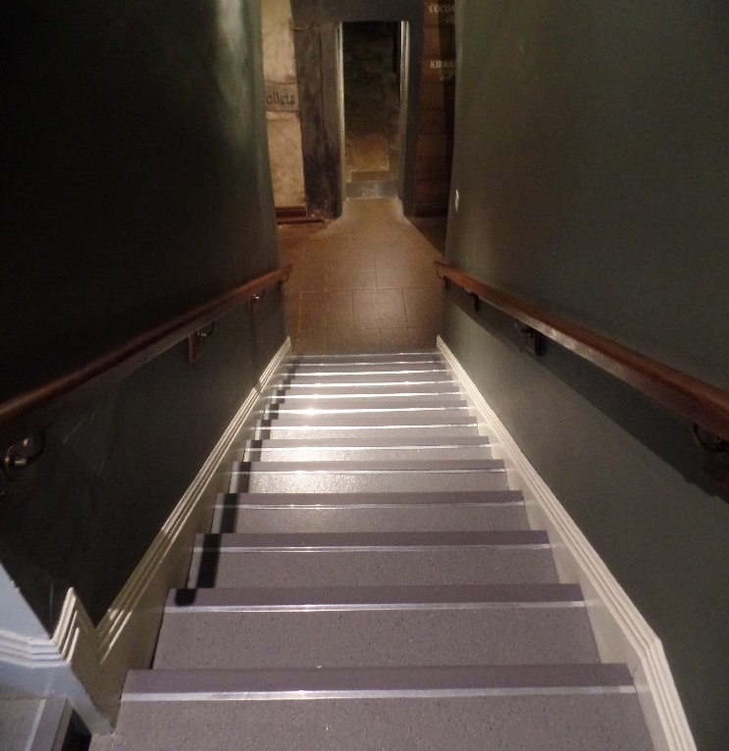

Further Information
- If you have any questions, please ask a member of staff. The museum staff all wear a purple shirt, black trousers or a skirt and have a lanyard with their picture and name on.
- York Castle Museum is part of York Museums Trust, which also includes York Art Gallery and the Yorkshire Museum. Please feel free to ask any questions about these other sites.

Feedback
- The York Castle Museum is continually aiming to improve accessibility. If you have any feedback about any aspect of your visit or any ideas on how we can improve accessibility, please speak to a member of staff or fill in a comment card.
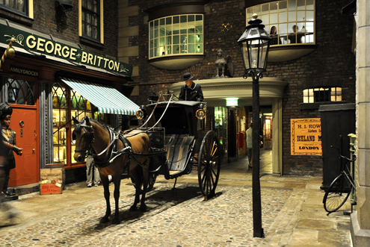

We hope you enjoy your visit!

